**PROJECT SYNOPSIS**

“**School Mangement System”**  
for

**Seth Anandram Jaipuria School, Sadhu Campus – Barabanki**

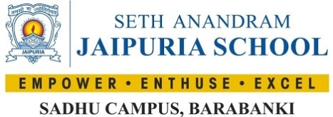

SYNOPSIS SUBMITTED FOR THE PARTIAL FULFILMENT OF THE

REQUIREMENT FOR THE THREE YEAR DIPLOMA IN

**“Computer Science and Engineering/Information Technology”**

**SUBMITTED TO**

“Mahamaya Polytechnic Of Information Technology ”

Hathras

**SUBMITTED BY:**

UTKARSH­ KUMAR

**(College Enrolment Number- E22113735500062 )**

**2022-2025**



**Under the Guidance of**

Er. Rohit Kumar

Senior Consultant

SOFTPRO INDIA COMPUTER TECHNOLOGIES (P) LTD

ABOUT THE ORGANISATION

Softpro India Computer Technologies (P) Ltd. is a leading IT firm and the software development division of Softpro Group of Companies with its headquarter located in the capital city of Uttar Pradesh, Lucknow. Softpro India was established in 2004 by technocrats from IIT-Kanpur and IET Lucknow. Softpro Group of Companies is a cluster of companies working in multiple domains like Software Development, IT Trainings, Research and Designing. The Founder and Managing Director of Softpro Group of Companies is Er. Ajay Chaudhary with over 25 years of experience. Softpro India is the fastest growing IT company with the largest learning center of the region having experienced consultants of 15+ years and industry experts.

Softpro Group of Companies compromises of Softpro Learning Center (Training & Internship division – 2008), Softpro Innovations (R&D division – 2014) and Softpro Foods (Agro Production division – 2018). Softpro India has global presence with its Head Office and Training Center located in Lucknow, International Unit Office located in Malawi, Africa and Virtual Office located in Kuala Lumpur, Malaysia. Softpro India has successfully delivered Government Projects like the visionary project of Government of Uttar Pradesh – *URISE.* Softpro India also has signed MoU with Department of Technical Education, Government of Uttar Pradesh making it the authorised Training & Development partners to impart and technically upskill all the engineering students of polytechnics (government, private & aided) across Uttar Pradesh.

Softpro India’s recent achievements include the MoU signing with Dr. A. P. J. Abdul Kalam Technical University, Uttar Pradesh. Technologies are transcending boundaries and their volatility is putting stringent demands on the time and mind-space of techno-professionals. At SPG, we update ourselves with technologies even before they become norms and master them long before they become redundant. That's why we are on the roster of clients from across the continents.

Softpro India offers training for all the ranches of engineering (Computer Science, Information Technology, Electronics, Electrical, Civil, Mechanical) for updated and trending technologies. Softpro India also has several online and offline trainings like Summer Training, Industrial Training, Vocational Training, Apprenticeship Program, Employment Training Program and Online Courses. The learning material and other resources are available on Softpro India’s Learning Management System (LMS) – “Polyprep – Knowledge @ Your Doorstep” and mobile application – “e-Study Zone”.

Come to think of it, we have engineered ourselves to be at the very forefront in Web based technology. Our core competencies span a spectrum of web-intensive services that range from website designing to robust backend management.

About BTEUP

State Board of Technical Education and Training was set up in the state in May,1958. The Board conducted its first examination in 1960, for courses of diploma level and also for Draughtsman Certificate Course. The name of the state Board was changed to Board of Technical Education in 1962. In the same Year, the U.P. Pravidhic Shiksha Adhiniyam - 1962 was enacted awarding the Board statutory status. In the year 1962, year of its inception, the Board held the examination of about 2500 students, in three major disciplines of Civil, Electrical and Mechanical Engineering at 25 different Centers/Institutions. It has a chairman, vice-chairman and 40 members, named by the state government. Secretary, Board of Technical Education, U.P. is ex-officio member secretary of the Board. The curriculum prepared by other institutions was adopted by the Board, till 1980 but thereafter the curriculum and syllabi were developed and revised, every five years at the Board level through its Curriculum development cell. The curriculum development work has been entrusted to I.R.D.T. Kanpur. The Board now examine and approve the syllabus developed by IRDT, Kanpur and prescribe it for institutions affiliated to Board of Technical Education, U.P. About 1,05,000 students in the 60 different disciplines of one year, two year, three year and four year durations are being examined at present, in the institutions, affiliated to the Board. The Board of has been constituted under U.P. Pravidhic Shiksha Adhiniyam - 1962. It has a Chairman and a Vice-Chairman and, 40 memebers nominated by the state Government. Secretary, Board of Technical Education is ex-officio member secretary of the Board.

SUMMER TRAINING

Summer training is an important part of the engineering curriculum. The summer training helps a student in getting acquainted with the manner in which his/her knowledge is being practically used outside his/her institute and this is normally different from what he/she has learnt from books. Hence, when the student switches from the process of learning to that of implementing his/her knowledge, he/she finds an abrupt change. This is exactly why summer training session during the B.T.E curriculum becomes all the more important. Summer training is prescribed for the student of Technical College as a part of the four-year degree course of engineering by the AICTE. We are required to undergo summer training for a period of 45 days after the completion of the 2nd year.

Summer Training allows industry exposure and understanding the working environment & it gives the industrial exposure. It is essential and helps to attain in-depth knowledge of the engineering stream. It enhances professional skills in a real-time environment. It helps us understand the area of interest and selection of an area of specialization. It also allows students to learn the basics of how to work as a team member to complete given tasks. It improves awareness of the industrial environment and work culture of the specific industry. It gives real-time work and the projects help to learn more analytically. It allows interaction with experts to solve queries with practical exposure. The Certificate obtained from reputed organization give weightage to resume or CV.

TECHNOLOGIES TRAINED ON DURING SUMMER TRAINING

1. **HTML: -** HTML is stand for hypertext markup language, this markup language is used to design static web pages. HTML contain pre-defined tags, which are useful to design web pages. HTML describes the structure of a Web page. HTML consists of a series of elements. HTML elements tell the browser how to display the content. HTML elements label pieces of content such as "this is a heading", "this is a paragraph", "this is a link", etc.
2. **CSS: -** CSS stands for Cascading Style Sheets. CSS describes how HTML elements are to be displayed on screen, paper, or in other media.CSS is the language we use to style an HTML document. CSS describes how HTML elements should be displayed. CSS saves a lot of work. It can control the layout of multiple web pages all at once. External stylesheets are stored in CSS files.
3. **Javascript: -** JavaScript is a scripting or programming language that allows you to implement complex features on web pages — every time a web page does more than just sit there and display static information for you to look at — displaying timely content updates, interactive maps, animated 2D/3D graphics, scrolling video jukeboxes, etc. — you can bet that JavaScript is probably involved. It is the third layer of the layer cake of standard web technologies, two of which (HTML and CSS).
4. **Bootstrap: -** Bootstrap is the most popular HTML, CSS and JavaScript framework for developing a responsive and mobile friendly website. It is absolutely free to download and use.It is a front-end framework used for easier and faster web development. It includes HTML and CSS based design templates for typography, forms, buttons, tables, navigation, modals, image carousels and many others.It can also use JavaScript plug-ins. It facilitates you to create responsive designs.
5. **Database: -** A database is an organized collection of data, so that it can be easily accessed and managed. You can organize data into tables, rows, columns, and index it to make it easier to find relevant information. Database handlers create a database in such a way that only one set of software program provides access of data to all the users. The main purpose of the database is to operate a large amount of information by storing, retrieving, and managing data.There are many dynamic websites on the World Wide Web nowadays which are handled through databases. For example, a model that checks the availability of rooms in a hotel. It is an example of a dynamic website that uses a database. There are many databases available like MySQL, Sybase, Oracle, MongoDB, Informix, PostgreSQL, SQL Server, etc.
6. **Python: -** Python is an open source, object oriented, high level programming language. Python is a general-purpose programming language. By using python language, you can develop different kinds of applications like desktop applications, web applications, ERP, etc. In project development we use python as main programming language. In this internship program we develop a web-based application named “**School Management System**”, In this web application we used Python with django framework.
7. **Django Framework: -** Django is a web framework developed by using powerful python programming language. It follows MVT architecture.

About School Management System

**Seth Anandram Jaipuria School, Sadhu Campus – Barabanki** is dedicated to the mission of 'Empower, Enthuse, and Excel,' ensuring that every child receives a holistic education that not only imparts knowledge but also instills values essential for navigating life. Our commitment at Seth Anandram Jaipuria School is to provide education that truly prepares students for LIFE!

Nestled in the serene environment of Barabanki, **Seth Anandram Jaipuria School, Sadhu Campus** spans 2.16 acres of lush green land. The campus is equipped with state-of-the-art facilities, designed to foster the all-round development of our students. Each classroom is outfitted with Digital Smart Boards, ensuring an interactive and engaging learning experience.

Our educational philosophy centers on a child-focused approach, where we identify and nurture the unique talents of every student. The school’s curriculum integrates contemporary pedagogical methods, including Design Thinking, and emphasizes Literacy and Numeracy Skills. We believe in cultivating not just intellectual abilities but also fostering values like compassion, empathy, kindness, solidarity, and tolerance, alongside encouraging critical thinking, analytical reasoning, and creativity.

Conventional Methods of School Management

Traditional school administration methods involve managing school operations manually, where administrators, teachers, and students rely heavily on paper-based processes. These methods typically include manual enrollment, where students fill out and submit physical admission forms, and teachers maintain paper-based records for attendance, grades, and communication. The process is often time-consuming and prone to delays, such as long waiting periods for processing admission applications or delivering important updates to parents and students. Additionally, communication between teachers, parents, and students is often limited to in-person meetings or delayed correspondence, leading to a lack of immediate feedback and responsiveness in addressing student needs or concerns. There is a pressing need for a modern, integrated platform that can transform these traditional school management practices. An advanced School Management System can streamline administrative tasks, enhance communication, and provide real-time access to critical information, ensuring a more efficient and effective school operation.

About School Management System

To address the challenges posed by traditional school administration methods, Seth Anandram Jaipuria School, Sadhu Campus – Barabanki, has introduced a comprehensive School Management System (SMS). This system is designed to digitize every aspect of school operations, from admissions to academic management, ensuring that all processes are streamlined and efficient.

The SMS features a **common zone** accessible to all visitors, providing a general overview and essential information about the school. Beyond this, the system offers three distinct login panels for **Students**, **Teachers**, and **Administrators**, each tailored to meet their specific needs:

* **Student Panel:** Students can log in to view their subjects, track their attendance, and manage their profiles. This allows them to stay informed and take responsibility for their academic progress.
* **Teacher Panel:** Teachers have the ability to mark attendance, view the subjects assigned to them, and manage their profiles. This ensures that teachers can efficiently manage their classes and stay organized.
* **Admin Panel:** Administrators have full control over the system. They can add, remove, edit, and delete student and teacher accounts, manage classes, add new subjects, and assign teachers to their respective subjects. This centralized control allows for smooth and effective school management.

Through this platform, communication and feedback between students, teachers, and administrators are streamlined, ensuring a seamless flow of information and prompt resolution of any issues. The system also enhances the digital experience by providing real-time access to educational materials, attendance records, examination results, and other essential resources.

This School Management System is set to revolutionize the way the school operates, making education more accessible, efficient, and effective for everyone involved.

Objective

The School Management System (SMS) at Seth Anandram Jaipuria School, Sadhu Campus – Barabanki, is designed with the objective to streamline and enhance the entire school administration process. This secure and robust web application aims to provide a centralized platform for managing all aspects of school operations, from student information and attendance tracking to academic management and communication.

The SMS is user-friendly and easily accessible, ensuring that all stakeholders—students, teachers, and administrators—can efficiently perform their tasks. The system is built on a cloud-based architecture, allowing for scalability and flexibility as the school’s needs evolve. It ensures that resources are available whenever needed, providing 24x7 secure access to authorized users from any location.

The SMS addresses key administrative challenges, such as student enrollment, class management, attendance tracking, and communication, ensuring that all aspects of school management are handled effectively. By providing real-time access to data and resources, the system facilitates better decision-making and enhances the overall educational experience for students, teachers, and administrators alike.

ABOUT THE PROJECT

The project is a **School Management System (SMS)** designed to enhance and streamline school administration. Below is an overview of the project's feasibility analysis and planning stages:

* **Feasibility Study**

Feasibility study assesses the practicality and benefits of developing the SMS for the organization. It is an ongoing process throughout the system life cycle.

* **Operational Feasibility:-**

The web-based application provides users with easy access to services, fulfilling their requirements efficiently.

It ensures proper management of user information, reduces manual workload, and simplifies handling of large databases.

The system minimizes the risk of data loss and aims to satisfy all users and end-users by improving operational efficiency.

.

* **Technical Feasibility:-**

For the design and development of the system, several software products have been accommodated.

* Database design – SQLite3
* Interface design – HTML, CSS, Java Script and Bootstrap.
* Coding – Python with Django Framework

The technology (Python with Django Framework) has enough efficiency for the development of the system. Therefore the project is technically feasible.

* **Schedule Feasibility:-**

The project timeline has been planned to align with the client's expectations.

The system is scheduled to be delivered within the agreed timeframe, making the project feasible in terms of scheduling.

* **Economical Feasibility:-**

The project's estimated costs align with the allocated budget.

The resources and budget are deemed sufficient for developing the SMS, confirming economic feasibility.

* **Project Planning & Scheduling:-**

Effective planning is crucial for software development. It involves defining features, estimating time requirements, and budgeting. The project follows a Software Development Life Cycle (SDLC) model, which includes:.

* Requirement Analysis - Identifying and documenting the system requirements.
* System Design: Creating design specifications based on requirements.
* Coding:- Developing the system using the chosen technologies.
* Testing - Ensuring the system functions correctly and meets quality standards.
* Implementation - Deploying the system for use by the school.
* Maintenance - Ongoing support and updates to ensure continued functionality.

The SDLC model ensures a structured approach to development, guiding the project from initial planning through to maintenance.

SOFTWARE REQUIREMENTS FOR DEVELOPMENT

|  |  |
| --- | --- |
| User Interface Designing | HTML5, CSS3, Java Script, Bootstrap |
| Programming Language | Python with Django Framework |
| Database | SQLite3 |
| IDE | VS Code |

HIGH Level Designing

**DATA FLOW DIAGRAM**

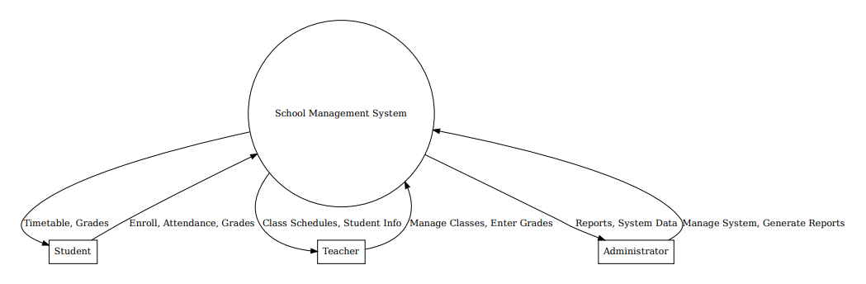

**1-Level DFD**

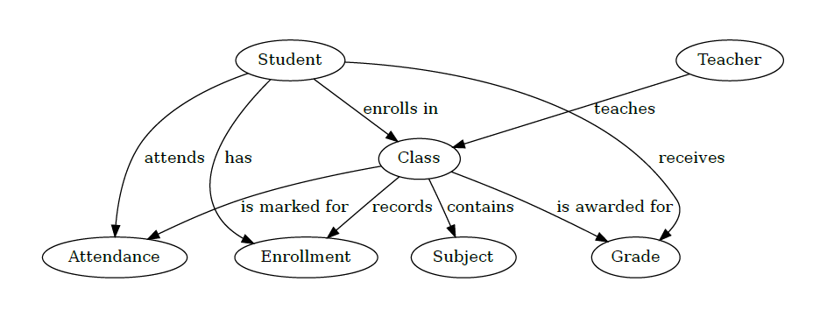

Low Level Designing

**Database Designing**

Table Name : tbl_student

|  |  |
| --- | --- |
| Column Name | Data Type |
| Rollno | int primary key |
| Name | varchar(50) |
| Fname | varchar(50) |
| Mname | varchar(50) |
| Gender | varchar(6) |
| Address | varchar(255) |
| Class | varchar(50) |
| Sfee | varchar(50) |
| Restfee | varchar(50) |
| Contactno | varchar(10) |
| Emailaddress | varchar(50) |
| Pic | varchar(200) |
| Regdate | varchar(30) |

Table Name : tbl_teacher

|  |  |
| --- | --- |
| Column Name | Data Type |
| Id | int primary key |
| Name | varchar(50) |
| Fname | varchar(50) |
| Email | varchar(50) |
| Gender | varchar(6) |
| Address | varchar(255) |
| Tclass | varchar(50) |
| Tsalary | varchar(50) |
| Contactno | varchar(50 |
| Emailaddress | varchar(10) |
| Pic | varchar(200) |
| Regdate | varchar(30) |

Table Name : tbl_login

|  |  |
| --- | --- |
| Column Name | Data Type |
| Userid | varchar(50) primary key |
| Password | varchar(30) |
| Usertype | varchar(50) |
| Status | Varchar(10) |

Table Name : tbl_enquiry

|  |  |
| --- | --- |
| Column Name | Data Type |
| Id | int primary key auto_increment |
| Name | varchar(50) |
| Gender | varchar(20) |
| Address | varchar(255) |
| Contactno | varchar(10) |
| Emailaddress | varchar(50) |
| Enquirytext | Varchar(255) |
| Enquirydate | Varchar(30) |

Table Name : tbl_class

|  |  |
| --- | --- |
| Column Name | Data Type |
| Id | varchar(50) primary key |
| Name | varchar(30) |
| Roomno | varchar(10) |
| Seats | Varchar(10) |

Table Name : tbl_subjects

|  |  |
| --- | --- |
| Column Name | Data Type |
| Id | varchar(50) primary key |
| Name | varchar(50) |
| Classid | varchar(50) |
| Teacherid | Varchar(50) |
| Book | Varchar(200) |

Table Name : tbl_attandance

|  |  |
| --- | --- |
| Column Name | Data Type |
| Id | varchar(50) primary key |
| Name | varchar(50) |
| Classid | varchar(50) |
| Teacherid | Varchar(50) |
| Book | Varchar(200) |

Table Name : tbl_question

|  |  |
| --- | --- |
| Column Name | Data Type |
| Qid | int primary key auto_increment |
| Question | varchar(255) |
| Postedby | varchar(50) |
| Posteddate | varchar(30) |

Table Name : tbl_answer

|  |  |
| --- | --- |
| Column Name | Data Type |
| Aid | int primary key, auto_increment |
| Qid | Int |
| Answer | varchar(255) |
| Answeredby | varchar(50) |
| Posteddate | varchar(30) |

Table Name : tbl_feedback

|  |  |
| --- | --- |
| Column Name | Data Type |
| Id | int primary key auto_increment |
| Rollno | Int |
| Name | varchar(50) |
| Class | varchar(50) |
| Contactno | varchar(10) |
| Emailaddress | varchar(50) |
| Subject | varchar(500) |
| Feedbacktext | Varchar(500) |
| Feedbackdate | varchar(30) |

Table Name : tbl_news

|  |  |
| --- | --- |
| Column Name | Data Type |
| nid | int primary key auto_increment |
| Newstext | varchar(255) |
| newsdate | varchar(30) |

Table Name : tbl_material

|  |  |
| --- | --- |
| Column Name | Data Type |
| Ids | int primary key, auto_increment |
| Program | varchar(50) |
| branch | Varchar(50) |
| Year | Varchar(50) |
| Subject | Varchar(100) |
| File_name | Varchar(255) |
| My_file | Varchar(255) |

Modules in Project

There are following modules in this project:-

* Student Information System
* Login Management System
* Discussion Forum Management
* Complain Management System
* Feedback Management System
* News Management
* Enquiry Management
* Study Material Management
* Email Integration
* SMS API Integration

Modules Description

**Student Information System:-** This module contains information of students with given fields like rollno, name, program, branch, year etc.

**Login Management System:-** This module validates user login. It also tracks user after identification of user whether he/she is admin or student.

**Discussion Forum Management:-** This module provides platform for students to ask question and give answer for given question. This is an important module to discuss on any topic and doubt clearance.

**Complain Management System:-** Through this module student can raise complain and student’s complain will show on admin panel, admin will resolve complain.

**Feedback Management System:-** Through this module, students can send feedback and student feedback will be shown on admin panel.

**News Management:-** Through this module, admin can post important news, which are displayed on notice board.

**Enquiry Management:-** In this module, any end user can raise enquiry, which display on admin zone.

**Study Material Management:-** Through this module admin can upload study material for students according to their course and subject. The study material is displayed on student panel.

**Email Integration:-** Through this module when student do registration a system generated email is send to student email id.

**SMS API Integration:-** Through this module when end user do enquiry a system generated SMS is send to end user registered mobile no.

Future Scope Of Project

The School Management System (SMS) is designed to adapt to evolving needs and technological advancements. Here are some key areas for future development:

* **Mobile Application Development**:
  + An Android application is planned to extend the system's accessibility, allowing students, teachers, and administrators to interact with the SMS through mobile devices. This will provide greater flexibility and convenience for users on the go.
* **Integration with Learning Management Systems (LMS):**
  + **Integration with LMS Platforms:** Future versions could integrate with popular LMS platforms to provide a seamless experience between administrative and educational management tools.
  + **Online Courses and Resources:** Expansion to support online courses, virtual classrooms, and access to digital educational resources.